MightyMouse Waterproof Optical Mouse
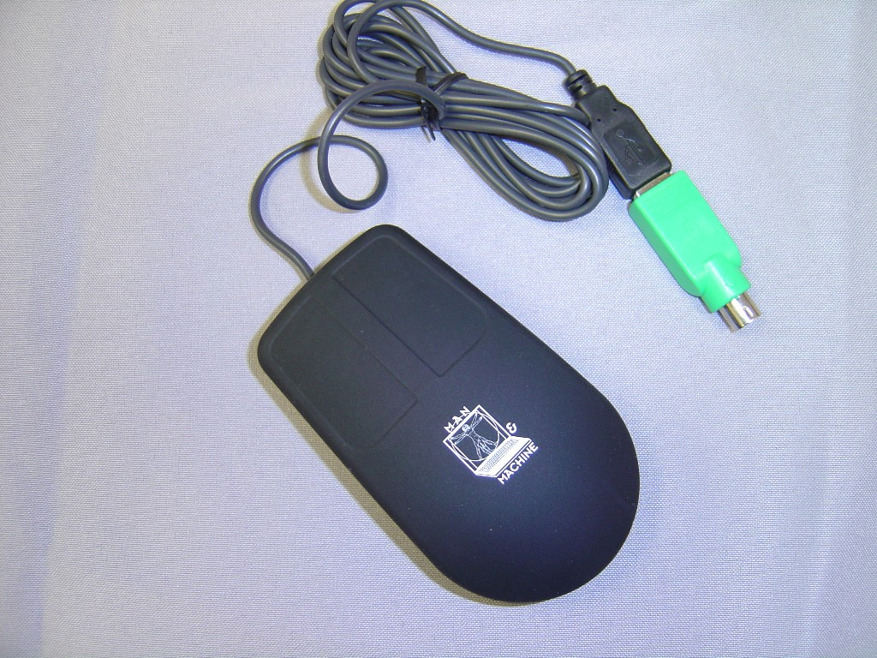

This optical desktop mouse is IP64 Waterproof, and great for medical, industrial, marine, and any environment where dust, moisture or liquid is a concern. The Mighty Mouse has a 6' USB cable, and is PS/2 compatible (PS/2 adapter included). This two-button mouse comes in black, and can be sanatized.

Technical Specification

Weight:  Approximately 142 g  5.0 oz  Dimensions:  Approximately 106 x 61 x 32 mm  4.2 x 2.4 x 1.3 inch  Cable length:  Approximately 1.83 m  6.0 feet  Storage temperature:  -20 °C up to 70 °C  -4 °F up to 158 °F  Operating temperature:  0 °C up to 70 °C  32 °F up to 158 °F | Composition:  100% Silicone Rubber  PVC Cable  System requirements:  PS/2 interface (PS/2 version)  USB interface (USB version)  Guaranteed period:  One year limited warranty

All specifications are subject to change without notice.

The MightyMouse can be cleaned with water, soap, alcohol, 10% bleach solutions, and a variety of chemical disinfectants.

DO NOT USE PETROLEUM BASED CLEANERS OR SOLVENTS

Federal Communications Commission (FCC) Statement

This equipment has been tested and found to comply with the limits for a Class B digital device, pursuant to Part 15 of the FCC Rules. These limits are designed to provide reasonable protection against harmful interference in a residential installation. This equipment generates, uses, and can radiate radio frequency energy and, if not installed and used in accordance with the instructions, may cause harmful interference to radio communications. However, there is no guarantee that interference will not occur in a particular installation. If this equipment does cause harmful interference to radio or television reception, which can be determined by turning the equipment off and on, the user is encouraged to try to correct the interference by one or more of the following measures:
Reorient or relocate the receiving antenna.
Increase the separation between the equipment and receiver.
Connect the equipment into an outlet on a circuit different from that to which the receiver is connected.

Properly shielded and grounded cables and connectors must be used in order to meet FCC emission limits. Man & Machine, Inc. is not responsible for any radio or television interference caused by using other than recommended cables and connectors or by unauthorized changes or modifications to this equipment. Unauthorized changes or modifications could void the user's authority to operate the equipment.

This device complies with Part 15 of the FCC Rules. Operation is subject to the following two conditions: (1) this device may not cause harmful interference, and (2) this device must accept any interference received, including interference that may cause undesired operation.

Responsible Party:
Man & Machine, Inc
3706 West St.
Landover, MD 20785
Telephone: 1-301-341-4900
http://www.man-machine.com/




Copyright Man & Machine, Inc. 2005

