Cool Series Waterproof Keyboard

ReallyCool
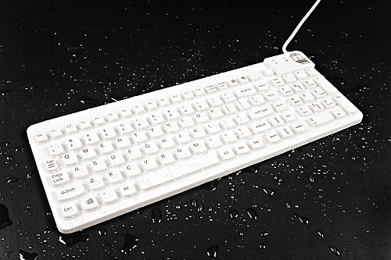
The ReallyCool is a water-resistant and contaminant proof keyboard with tactile feedback keys. The sealed and rigid surface is ideal for industrial, marine, and medical use, as well as other applications where moisture, cleaning, and durability are a consideration. Because the ReallyCool is also quieter than "standard" keyboards, they are great for applications where noise generated from “key-clicks” is a problem. The ReallyCool is compatible with standard keyboard layouts and drivers are not needed.

Technical Specifications

Weight:  Approximately 817 g (1.8 lb.)  Dimensions:  381 mm x 140 mm x 15.3 mm  15” x 5.5” x 0.6”  Cable length:  Approximately 1.83 m (6’)  Storage temperature:  -20 °C - 70 °C  -4 ° F - 158 °F  Operating temperature:  0 °C - 70 °C  32 °F – 158 ° F | Current input:  Approximately 26 mA  Composition:  100% Silicone Rubber  PVC Cable  Latex free keyboard  System requirements:  USB interface (USB version)  PS/2 interface (PS/2 version)  (USB to PS/2 Adapter Optional)  Number of keys:  104 = US Layout with Windows ™ keys  plus two additional function keys  Guaranteed period:  One year limited warranty

All specifications are subject to change without notice.
The ReallyCool can be cleaned with water, soap, alcohol, 10% bleach solutions, and a variety of chemical disinfectants.

DO NOT USE PETROLEUM BASED CLEANERS OR SOLVENTS

Installing Your ReallyCool Keyboard

PS2
- Turn off your computer and all attached devices. If you have another keyboard attached, disconnect it.
- Attach the PS2 keyboard cable to the keyboard port.
- Turn on your computer to activate the keyboard.
(There is no software to install.)

USB
- Attach the keyboard cable to the keyboard port. (You do not have to turn off your computer. There is no software to install.)

Federal Communications Commission (FCC) Statement

This equipment has been tested and found to comply with the limits for a Class B digital device, pursuant to Part 15 of the FCC Rules. These limits are designed to provide reasonable protection against harmful interference in a residential installation. This equipment generates, uses, and can radiate radio frequency energy and, if not installed and used in accordance with the instructions, may cause harmful interference to radio communications. However, there is no guarantee that interference will not occur in a particular installation. If this equipment does cause harmful interference to radio or television reception, which can be determined by turning the equipment off and on, the user is encouraged to try to correct the interference by one or more of the following measures:
Reorient or relocate the receiving antenna.
Increase the separation between the equipment and receiver.
Connect the equipment into an outlet on a circuit different from that to which the receiver is connected.

Properly shielded and grounded cables and connectors must be used in order to meet FCC emission limits. Man & Machine, Inc. is not responsible for any radio or television interference caused by using other than recommended cables and connectors or by unauthorized changes or modifications to this equipment. Unauthorized changes or modifications could void the user's authority to operate the equipment.

This device complies with Part 15 of the FCC Rules. Operation is subject to the following two conditions: (1) this device may not cause harmful interference, and (2) this device must accept any interference received, including interference that may cause undesired operation.

Responsible Party:
Man & Machine, Inc
3706 West St.
Landover, MD 20785
Telephone: 1-301-341-4900
http://www.man-machine.com/




Copyright Man & Machine, Inc. 2005

